Sewage backups and overflows are typically the result of grease buildup which can cause property damage, environmental problems and other health hazards.
Fats, oils and grease get into the sewers mainly from commercial food preparation establishments that do not have adequate grease control measures in place such as grease interceptors. Most grease is the byproduct of cooking and is usually found in such things as:
 |  |  |  |  | - Food scraps  - Meat fats  - Lard  - Cooking oil |  |  |  |  |  |  | - Butter and margarine  - Baking goods  - Sauces  - Dairy products
 |  |  |  |  |  |  |  | 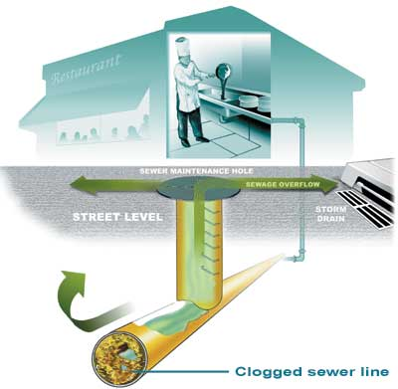
All too often, fats, oils and grease are washed into the plumbing system, (usually through kitchen sinks and floor drains found in food preparation areas) and stick to the insides of sewer pipes both on your property and in the streets.
Over time, fats, oils and grease builds up and eventually blocks the entire pipe causing sewage backups and overflows.
The image below is a photograph taken of a sewer line via a remote Closed Circuit Television (CCTV). and shows the accumulation of hardened grease around the sewer pipe interior.
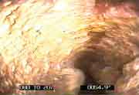
 | Costs To Your Business: |  |  |  |  |  |  |  |  |  |  |  | Costs To You
 | 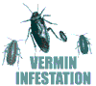
 |  | As your sewer pipes back up, sewage and food particles that accumulate can attract insects and other vermin and may create potential health hazards. |  |  |  |  |  |  |  |  |  | Clogged sewers can lead to overflows.  As sewage overflows onto streets, it enters the storm drain system...
 | 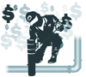 | Property damage can result from sewage backups leading to expensive cleanup and plumbing repairs that may have to be paid for by you. |  |  |  |  |  |  |  |  |  | ...where the sewage is then carried to our local beaches, creating a health risk for swimmers, marine life—and causing beach closures.
 |  | Health code violations or closures can greatly impact your business operations.
Increased sewer blockages and overflows lead to excessive and costly maintenance and can result in severe fines from the regulatory agencies.
This can increase your sewer fees.

Proper Disposal Methods
To stop sewage backups and overflows, you need to keep fats, oils and grease out of the sewer system. The most effective solution is to control fats, oils and grease at the source. Here’s how:
- Install a grease interceptor that’s sized and manufactured to handle the amount of grease byproduct anticipated.
- Maintain your grease interceptor in proper operating condition by having it cleaned and serviced on a frequent basis.
- Implement these Best Management Practices:
  - Scrape grease and food scraps from trays, plates, pots, pans, utensils, and grills (or other cooking surfaces) into a can or the trash for disposal.
  - Do not put grease down garbage disposals. Use baskets or strainers in sink drains to catch food scraps and other solids—and dispose of it in the trash.
 | 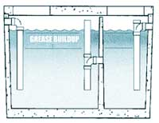

Don’t pour grease into kitchen sinks, floor drains or toilets. Instead, recycle all used grease.

4. Be cautious of chemicals and additives (including soaps and detergents) that claim to dissolve grease. Some additives simply pass grease down pipes where it can clog sewer lines in another area.

